Empathy Map

Introduction
An empathy map is a collaborative visualization tool used to better understand the needs, thoughts, feelings, and behaviors of users. It helps identify user expectations and challenges while designing a solution. For the Human Development Index (HDI) Prediction project, the empathy map focuses on users such as researchers, students, policy makers, and government organizations who need an efficient way to estimate HDI values.

Target Users
The proposed system is designed for:
- Students
- Researchers
- Government Organizations
- Data Analysts
- Policy Makers
- Educational Institutions
These users require a quick, accurate, and user-friendly method to predict Human Development Index values using socio-economic indicators.

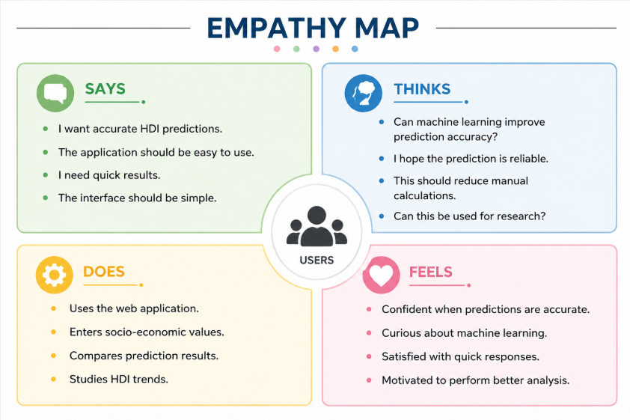

Pain Points
Users may experience the following challenges:
- Manual calculation of HDI requires significant effort.
- Large datasets are difficult to analyze manually.
- Existing methods can be time-consuming.
- Users may not have expertise in statistical analysis.
- Lack of simple prediction tools.

User Needs
The proposed application should provide:
- Accurate predictions
- Fast processing
- Easy navigation
- Reliable results
- Simple user interface
- Minimal user input

User Goals
The primary goals of the users include:
- Predict HDI quickly.
- Reduce manual effort.
- Analyze development indicators efficiently.
- Improve research productivity.
- Support educational learning.

Gains
The application provides several benefits:
- Faster prediction process.
- Better understanding of HDI indicators.
- Easy access through a web browser.
- Improved decision-making.
- Practical implementation of machine learning.

Opportunities
Future improvements can include:
- Integration with real-time datasets.
- Visualization dashboards.
- Cloud deployment.
- Multiple machine learning models.
- Mobile application support.

Conclusion
The empathy map provides a clear understanding of the expectations and challenges faced by users of the HDI Prediction system. By considering users' thoughts, needs, pain points, and goals, the application can be designed to deliver an intuitive, reliable, and efficient experience. This analysis ensures that the project remains user-centric and aligns with real-world requirements.

